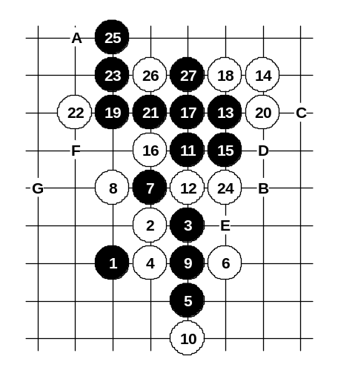

Diagram i2-83
Another 16th move.
Move 17-17 prepares the attack and blocks white structures as well. If 24-A then 25-B.
If 18-B then 19-C, 20-20, 21-D.
If 18-19 then 19-E, 20-B, 21-D.
If 18-E then 19-19, 20-21, 21-26, 22-25, 23-F, 24-G, 25-D.
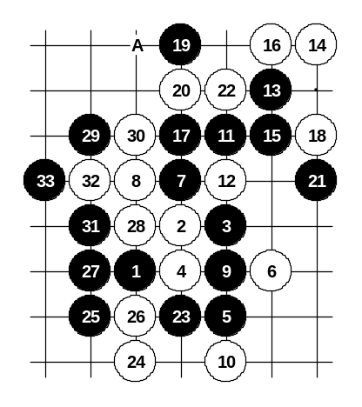

Diagram i2-84

Another 16th move.
In my i3 opening analysis I used 19-20, but here it does not work because of smaller space in upper side. Therefore I had to find 19-19 which is suitable because of connections through lower side.
If 20-22 then 21-A.
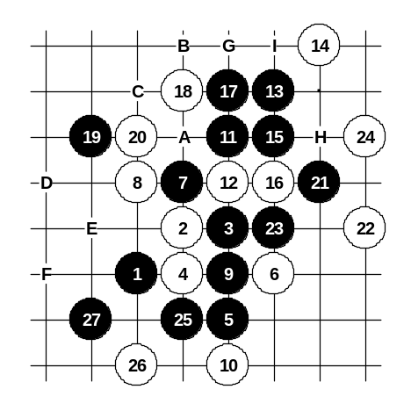
If 18-30 then 19-19.

Another 16th move. Black win is not easy. So far, only 17-17 and 19-19 seem to give black win. I did not find any other solution. If 20-A then 21-21, 22-22, 23-B, 25-C. If 20-B or 20-21 then 21-D, 22-E, 23-F and black wins.

Diagram i2-85
If 16-G then 17-24, 18-H, 19-21, 20-23, 21-17.
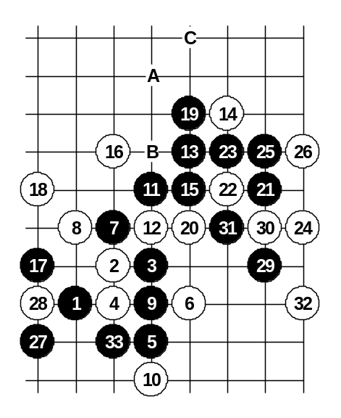
If 16-17 then 17-I, 18-16, 19-H.

Diagram i2-86
The last choice of 16th move. Black win is really complicated. I have not found any straight style win after long time of analyzing. The winning method I suggest is full of development moves. However, it seems that black wins for sure, without any exceptions. Move 17-17 is the key move. It helps to connect all black attacking material and prepares to stretch them towards the left side space. Move 18-18 tries to stop that development but now the lower side connection is open.
If 24-A then 25-25, 26-B, 27-C, 29-29 and VCF.

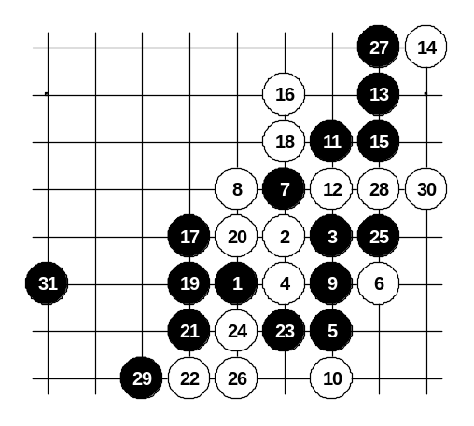
Another 18th move.

Diagram i2-87
Although black has lots of attacking material, it is not easy to find the win. In fact, the win comes only by using the “activate two areas and lose tempo” method. Moves 25-25, 27-27, 29-29 prepare black attacking base on both left and right side. Although white has got a tempo on move 30, it is useless because it cannot stop both sides at the same time.
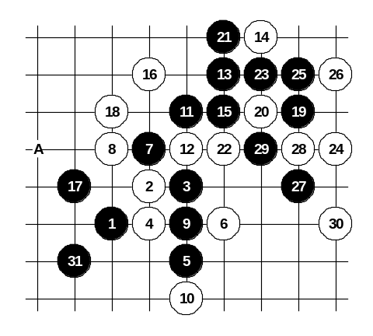

Diagram i2-88

Another 18th move.
Black wins in similar style as shown on the diagram i2-86.
If 18-A then black wins exactly in the same way.

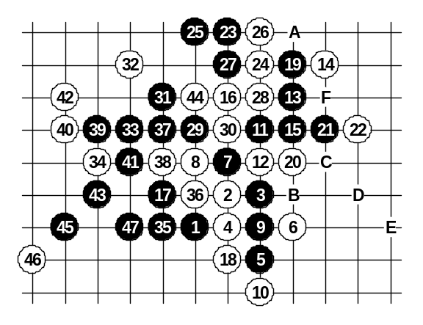

Diagram i2-89
Another 18th move.
It blocks the “lower gate”. Therefore black has to use the “upper gate” to connect the forces. Although the variant is long, it is very straight and clear and does not require explanations for side variants.
If 20-A then 21-22, 22-21, 23-B, 25-C, 27-D, 28-E, 29-37, 30-38, 31-26, 32-F, 33-27.
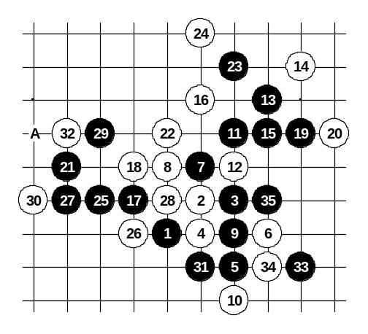

Diagram i2-90

Another 18th move.
Only the perfect sequence of moves can let black win here – 19-19, 21-21(!), 23-23, 25-25.
If 28-30 then 28-31.
If 26-28 then 27-A and black has total space control.

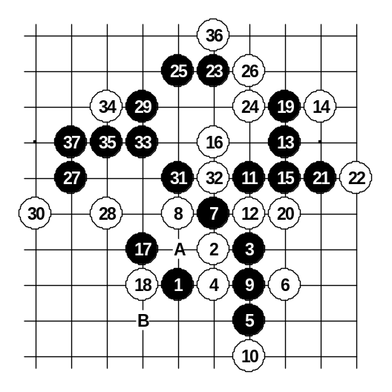

Diagram i2-91
Another 18th move.
On the diagram the main idea of the attack is shown.
If 30-35 then black has VCF.
Other 26th and 24th moves do not help either.
If 18-A or 18-B then black attacks in similar way and wins even easier.

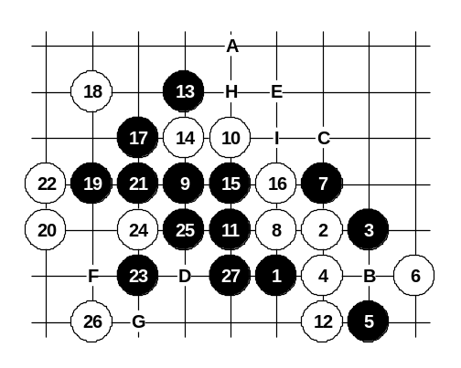

Diagram i2-92
Another 8th move. It is the strongest defense move. However, because of its passive structure, black can easily develop very powerful attack. I believe that move 9-9 is the best development. In case of any other 9th move white may have a chance to defend. For example, if 9-10 or 9-15 then 10-9 is a very powerful defense. On the diagram black prepares winning position with moves 11-11 and 13-13.
If 20-A then 21-24.
If 10-B then 11-11, 12-12, 13-16, 14-15, 15-C, 16-D, 17-14 (if 12-17 then 13-15).
If 10-15 then 11-11, 12-14, 14-12, 15-24, 16-17, 17-10, 18-E, 19-F, 21-G (if 18-F then 19-E, 21-H).
If 10-15, 11-11, 12-12 then 13-17, 15-14.
If 10-16 then 11-11, 12-12, 13-B, 14-any, 15-17, 17-10.
If 10-I then 11-12.
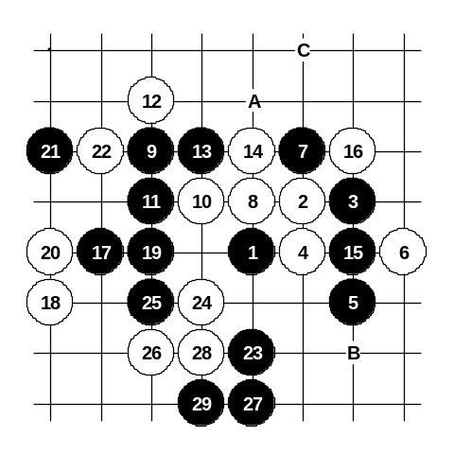

Diagram i2-93

Obviously this 10th move is the best resistance.
Move 11-11 – natural continuation.
Several 12th moves are worth to take a look at.
On this diagram, if 18-A then 19-19.
If 16-B then 17-A, 18-C, 19-22.

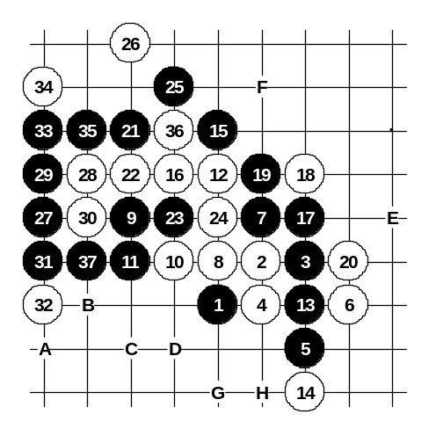
Another 12th move.

Diagram i2-94
The source point 13 is very important in several positions. Black can develop several connections through that point.
If 32-33 then 33-A, 35-B, 37-D, 39-D.
If 20-25 then 21-E.
If 16-22 then 17-16, 18-F, 19-35.
If 16-19 then 17-22, 18-21, 19-16, 20-37, 21-30.
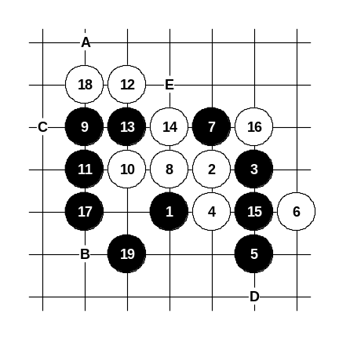
If 14-17 then 15-G, 16-19, 17-H.

Another 12th move.

Diagram i2-95
Surprisingly black can win with straight attack from move 13.
If 18-A, 20-B then 21-C.
If 16-D then 17-E and black wins in few moves regardless of how white defends.
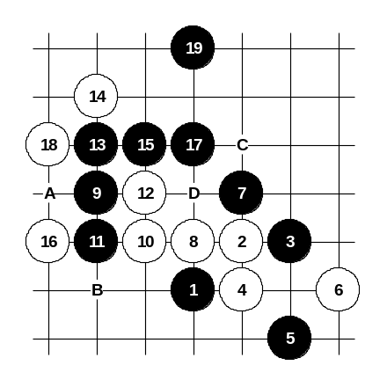

Diagram i2-96
Another 12th move.
It is quite weak. After obvious development 13-13, 14-14, 15-15 there is no defense.
If 20-A then black has VCF.
If 14-B then 15-15, 16-C, 17-D and black wins.
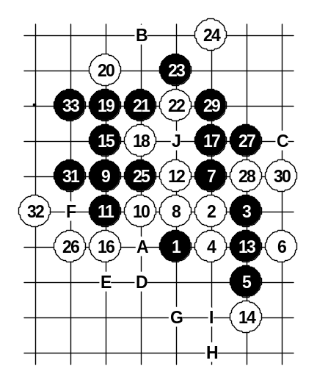

Diagram i2-97
Another 12th move.
Beautiful 25-25 connects the sides. After 26-26 black cannot win straight on the left side, therefore black plays 27-27 and 29-29 in order to create additional connections through the upper side. Now, after 34-A, black has VCF. If 30-B then 31-C. If 16-19 then 17-18. If 14-28 then 15-16, 16-15, 17-D.
If 14-28, 15-16, 16-E then 17-D, 18-F, 19-G, 20-H, 21-I (if 18-G then 19-18, 20-J, 21-F).
If 12-13 or 12-28 then 13-15, 14-any, 15-18.
If 12-31 then 13-15, 14-19, 15-13, 16-28, 17-G.

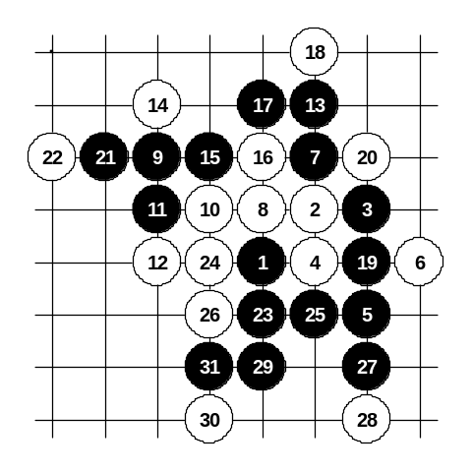

Diagram i2-98
The last choice of the 12th move. It is the strongest defense. Move 13-13 prepares the space for the attack. Move 14-14 is the only considerable move. Other 14th moves lose fast. Move 21-21 is the important key move. On the diagram black wins easily because white did not block black’s diagonal line.
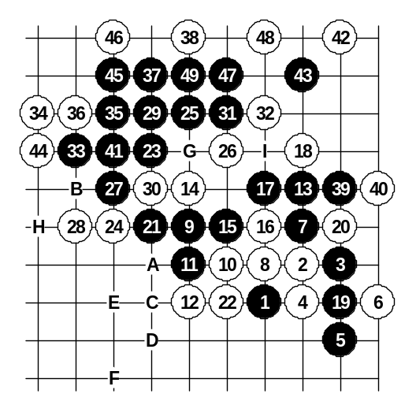

Diagram i2-99

Here white blocks the important black’s diagonal line from the bottom. The space on the left and upper side is sufficient for black win. If 30-A then 31-B. If 30-37 then 31-36, 32-34 and black VCF. If 28-47 then 29-C, 31-A, 33-D, 35-E. If 28-D, 30-47 then 31-28, 33-B. If 24-28 then 25-C, 27-30, 29-41. If 24-F, 26-28 then 27-29, 28-30, 29-41, 30-G, 31-B, 32-H, 33-I.
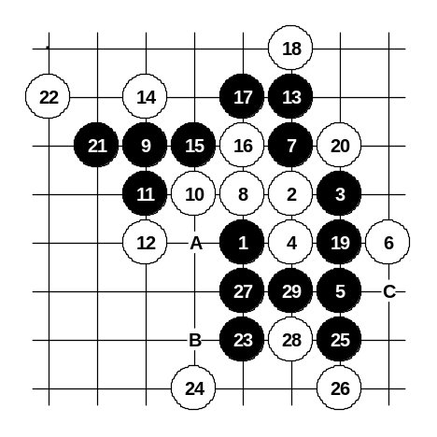

Diagram i2-100
This 22nd move is the last white chance. However, black begins powerful development on lower side. Move 24-24 tries to stop black development towards left lower corner, but black wins easily after that.
If 28-A or 28-B then 19-C.
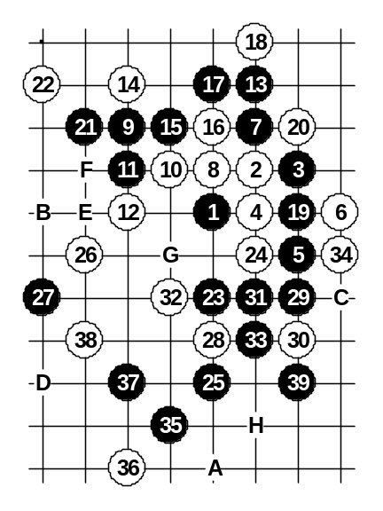

Diagram i2-101
The best 24th move.
Black still wins after beautiful 25-25.
If 38-A then 39-B.
If 34-35 then 35-39.
If 32-C then 33-D, 35-35.
If 26-28 then 27-E, 29-26, 30-F, 31-29, 33-31, 34-32, 35-33, 36-34, 37-39, 38-G, 39-H.
If 26-26, 28-29 then 29-37.

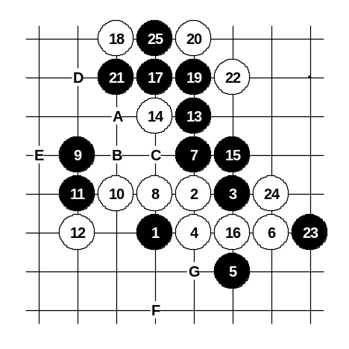

Diagram i2-102
Another 14th move.
Although it seems like a natural move, black wins easily here. If 14-A then 15-B, 16-C, 17-D and black can very easily create winning development after any 18th move (point E will be a key point for black in most of the variants). The conclusion about this 8th move: Because of its passive structure, it was possible to prove black win beginning with 9-9. If 8-16 then 9-C. If 8-10 then 9-16, 10-15, 11-F. If 8-G then look at the diagrams i2-76 – i2-79.
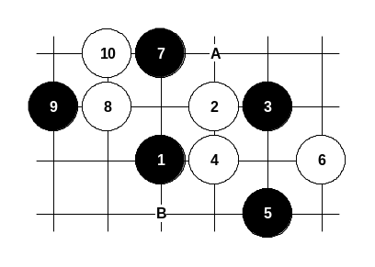
Those who prefer more peaceful development in this opening may try 7-7 instead of 7-A. Black has an advantage, but it is not easy to prove win there. Not that if similar pattern comes from i3 opening then move 11-B gives black win, but here it does not work because of smaller space.

Diagram i2-103
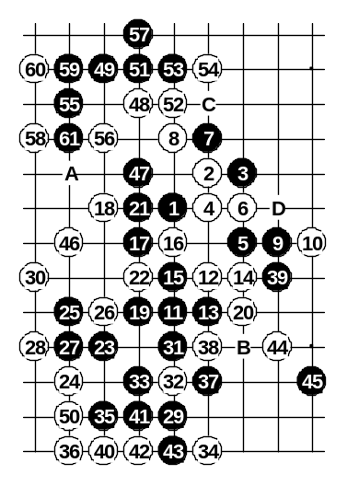
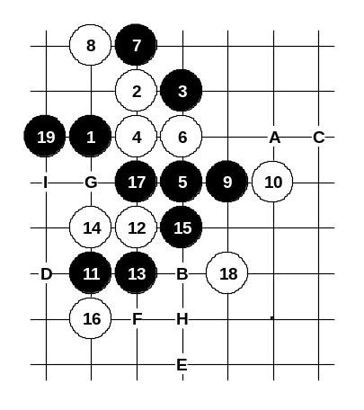
This is the best 6th move. In fact, this is the best white defense in i2 opening. Black win is difficult to be proved. Move 7-7 is the best. Move 8-8 is the only possible choice. If 8-D then 9-8. If 8-52 then 9-9. The variant on this diagram is very interesting. Although the attack is long, all moves are forced beginning from 15. If 62-A then black has VCF. If 54-59 then 55-B, 57-C. If 30-33 then 31-37. If 20-26 then 21-22, 22-21, 23-20, 25-23. If 18-B then 19-19, 20-26, 21-22. In fact, black can win even faster by playing 37-41. It is quite tricky win.

Diagram i2-104

Diagram i2-105
Another 14th move.
Black gets winning position by the 19th move.
If 16-A then 17-B, 18-C, 20-D, 21-17, 22-18, 23-E, 25-F.
If 14-B then 15-G.
If 14-D then 15-14, 16-G, 17-H, 19-15.
If 14-16 then 15-I.
Any other 12th move does not save either.

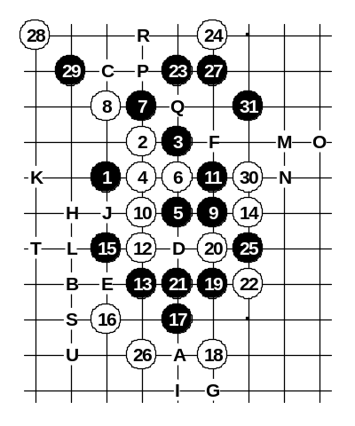
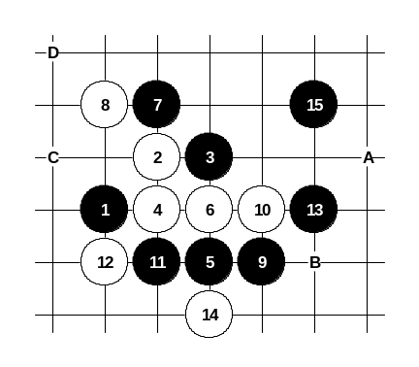
Another 10th move. Move 15-15 is the key of black win. If 30-A then black has VCF. If 24-B then 25-C, 27-27, 28-29, 30-D, 31-25 and black has VCF. If 22-E then 23-25, 24-26 and black has VCF. If 20-F then 21-21, 22-22, 23-A, 25-G. If 18-H then 19-19, 20-20, 21-21, 22-22, 23-25, 24-26, 25-A, 27-I, 29-G. If 16-D then 17-E, 18-J, 19-H, 20-K, 21-21, 22-19, 23-B, 25-L. If 16-E then 17-F, 18-20, 19-M, 20-N, 21-O, 23-30, 25-P, 26-29, 28-Q, 29-R. If 16-21 then 17-16, 18-D, 19-H, 20-K, 21-S (if 20-17 then 21-T). If 16-21, 17-16, 18-U then 19-20, 20-19, 21-P and black develops the attack towards left side through upper side.

Diagram i2-106

Diagram i2-107
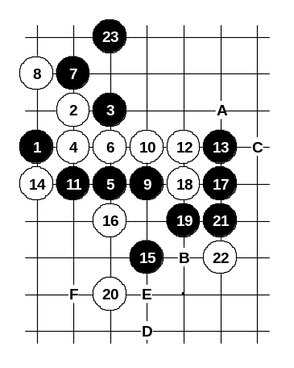
The last choice of the 10th move. Black develops towards upper space and black’s attack is very strong. If 14-A then 15-14 and black wins in the style similar to diagram i2-64. If 14-B then black develops the attack towards upper side either through points C and D or A and some move nearby A.

Diagram i2-108

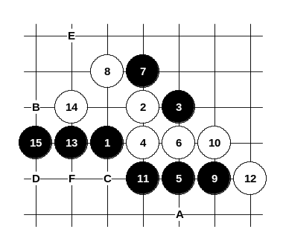
White plays four at move 12 and black position becomes even stronger. If 22-A then 23-22, 25-B. If 20-C then 21-D. It is also possible to play some space moves immediately in move 15 such as 15-E or 15-F, etc.

Diagram i2-109
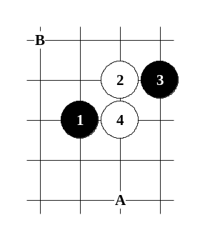
Another 12th move. White has completely blocked the right side, but black can still easily develop on the opposite side. In fact, the number of possible attacks is quite big. On the diagram one of the examples is shown. If 14-A then 15-B, 16-C, 17-D. If 14-C then 15-15 or 15-E depending on player’s concept of the attack. If 14-F then 15-B or 15-E.

Diagram i2-110
Those who want to try something new and unexplored, they may try to play 5-A or 5-B. There are no sure conclusions about it yet. Only a few games have been played using these moves. Black has got good positional advantage in most cases. It seems that white has to try to play actively in order to break black’s space control.

